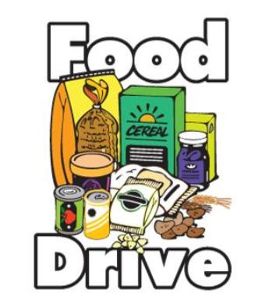
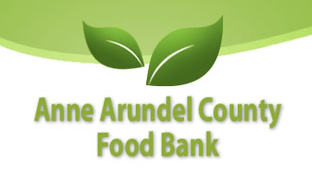
As you are shopping today, please buy some of the items on the bottom of this sheet and donate them in the boxes on your way out. The AA County Food Bank gives food to local soup kitchens, homeless shelters, and churches who distribute food to the hungry.

Monetary donations are accepted (checks made out to SRHS)! For $5, the AA County Food Bank can purchase 40 lbs. of food!

We are here today from 10am-3pm. Thank you! ~Sponsored by the Interact Club at South River HS

NO GLASS ITEMS!

MEAT & PROTEIN
Canned meat (tuna, ham, chicken)
Peanut butter
Macaroni and cheese
Canned stews
Soups
Powdered milk

BREADS & CEREALS
Oatmeal
Breakfast cereal
Rice and rice cakes
Pasta

FRUITS & VEGETABLES
Canned fruits
Canned vegetables
Canned soup

OTHER FOOD ITEMS
Pudding and custard
Nuts and seeds
Sauces and salad dressing

